Ramadan End Eid Party 10/04/2024

Lesson 152 and 153

What Really Matters in This Section and The idea Behind Git Tags

<https://www.canva.com/en_gb/login/?redirect=%2Fdesign%2FDAEV5aEpUOQ%2FlfUIjJz2atC6fGT9KOv2kg%2Fview>

Lesson 154

A side Note On Semantic Versioning

<https://semver.org/>

<https://getbootstrap.com/docs/versions/>

<https://legacy.reactjs.org/versions/>

When there is minor release you need to reset the patch back to 0.

Lesson 155

Viewing & Searching tags

<https://git-scm.com/docs/git-tag>

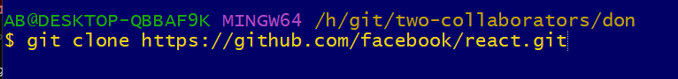

-l meaning list all the tag

This is mean exactly 17

This is searching and list “\*beta\*”

Lesson 156

Comparing Tags With Git Diff

I made the branch base on the particular version 15.3.1

Lesson 157

Creating Lightweight Tags

I want to tag this as new release.

That is example of light weight

Lesson 158

Creating Annotated Tags

Now I will create my tag

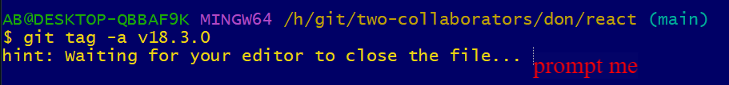

Close the tag



How do I see who made the tag?

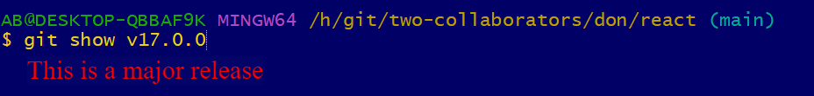

Lesson 159

Tagging Previous Commits



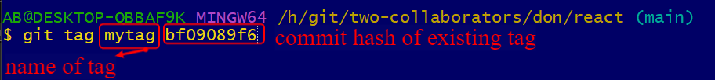

Now run the command git tag

Now run git log –oneline

My tag is below

Lesson 160

Replacing tags With Force

Run git log –oneline



Choose the above tag. Git does not like reusing the same tag

I made mistake I want the tag to point to different commit hash

I will use 41950d14a

But already exist. I want to move that tag and I to another commit

The tag has been moved down

Lesson 161

Deleting Tags

Run git log –oneline



I have 2 tags pointing to dsame commit and I want to delete one

Run git log –oneline



The other one is gone.

Lesson 162

Important: Pushing tags

Now I want to push one tag

I cant push here

Will push to colt

1 tag

In conclusion tags are not included when you push